Past Charity Information
2021 MBTA Charity
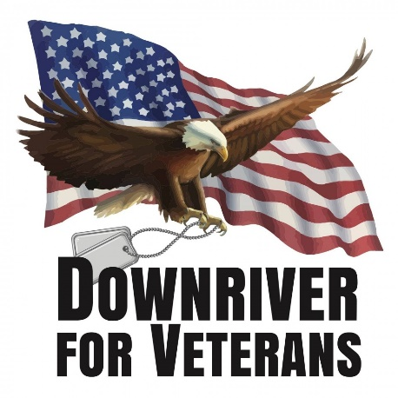
The MBTA Charity Committee and Executive Board have selected Downriver for Veterans. We are thrilled to showcase such an amazing organization with so much heart. Founded by Ann Rudisill, who is also an Air Force Veteran herself. Her dedication when she realized there were not a lot of resources for veterans who lived in the downriver communities (without going to downtown Detroit), took it as her mission to help them.

2019 MBTA Charity

MBTA 2019 Charity Sponsor



Mojo started Mojo in the Morning's Breaking and Entering Christmas Wish after hearing his radio buddy Tommy Sablan execute it in his city for his radio station. Mojo called and asked if he could do it too in Detroit, Tommy was honored and thus about 15 years ago Mojo began making Christmas wishes come true out of money from his own pocket. Since then, Breaking and Entering has grown into a non-profit that has since helped HUNDREDS of families. All funds collected go towards gifts, clothes and food for the holidays plus bills to help get needy listeners through the rough times. In just 2018 alone we donated $100,000 in cash and goods to needy families. We hope to continue to grow and help more listeners than ever before in 2019.

2017 MBTA Charity


We hope you enjoyed yourself at the December 7th Holiday Charity Event.

With all of your help, we're proud to announce we raised $8,296 for Macomb County Rotating Emergency Shelter Team (MCREST)!

Thank you again for another great year and for your donated silent auction items, raffle ticket prizes, and personal items for the homeless!! We thank you for bidding high and bidding often!!!!

MCREST is the 2017 charity chosen for GBTA Michigan Chapter. MCREST stands for Macomb County Rotating Emergency Shelter Team. MCREST provides shelter for men, women, children and families for up to 90 days.
Please check out their website at www.mcrest.org and see what churches participate in this program. We will be planning some volunteer events for GBTA members to participate in the coming months.
We can all make a difference by donating our time, supplies and through donations from the MBTA golf outing charity raffle and the holiday event charity auction

The MBTA Charity Committee is NOW accepting Silent Auction items for the Holiday Meeting.
Your donations go a long way to help those in need! And our members see how generous you are with each bid they make on the item(s) you have donated to this great event. This tradition dates back to the late 1980’s with each year growing with more donations and contributions to wonderful causes!
If you are able to donate please fill out the attached “2017 Holiday Donation Request” form and return this it to one of the Charity Committee members; Kathy Mastin; Kim Burns; Jodie Duncan; Alex Lenko; Sandy Chwierut or Sue Jarvis.
2016 MBTA Charity

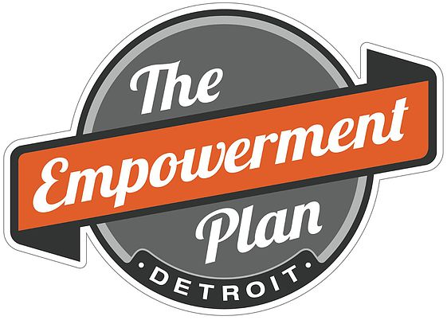
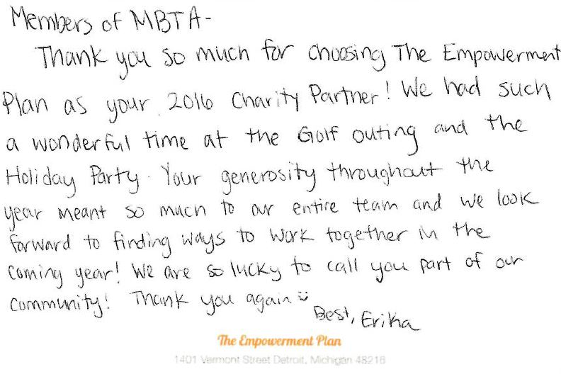
Dear Members,
We’re ecstatic to announce that we raised $10,591 for The Empowerment Plan at the Dec. 1st holiday event through the raffle tickets and silent auction items. We had some really great donations this year thanks to those of you who donated items. Thank you for all your contributions either by donating items or purchasing raffle tickets or silent auction items. You help make this all possible!!
In total for 2016 we raised $13,326 for The Empowerment Plan not including the $2,000 grant they received from the Enterprise Foundation.
Thank you for all your generous support in 2016!!!
Happy Holidays,
The Charity Committee

We’re proud to have chosen The Empowerment Plan for our 2016 charity. The Empowerment Plan is a non-profit that is an American humanitarian organization, located in Detroit, MI. The organization works to address homelessness by providing jobs to homeless women, and by manufacturing a coat that transforms into a sleeping bag that is given to homeless individuals in need.
The EMPWR coat is a water-resistant and self-heating jacket, which can transform into a sleeping bag, or be worn as an over-the-shoulder bag when not in use (Each coat costs $100). The coat is constructed of upcycled automotive insulation, fabric from Carhartt, and other materials provide by generous donors.
Please visit their website Empowerment Plan
We will be collecting men’s & women’s new packages of socks and underwear along with clean gently used casual adult clothing at our in person GBTA, Michigan Chapter meetings on Sept. 15th, and our Holiday Party - Dec. 1st.
Our committee’s goal for 2016 is to raise over $10k, which would provide over 100 coats to help those less fortunate.
We’ll have a raffle at our annual golf outing and a raffle and silent auction at the holiday party to raise money for the coats. Attached below is the request for donations for the holiday party event in December.
We look forward to your continued support in helping us reach our goal!
Regards,
Kathy Mastin, Committee Chair
2016 Golf Outing Charity Proceeds
Thank you to all who attended our meeting and golf outing event on Monday, June 13th. It was a real success!! With your generous support we were able to raise $2,735 for The Empowerment Plan not including the $2,000 grant that the Enterprise Foundation provided. That’s 47 coats!!!
Thank you to those of you who brought in food donations for The Empowerment Plan food pantry!! Thank you for another great event and your generous donations!!!!
We’ll now start accepting holiday charity donations for the December 1st GBTA / Michigan Chapter Holiday Event.
2016 Request for Donations
Golf Outing Raffle Ticket WINNERS!!!!!!
1ST Prize – Two Round Trip Comfort + Delta Air Lines Tickets – Kyle Kraft, Sabre
2nd Prize - $500 AMEX Gift Card – Kathy Mastin, Visteon Corp.
3rd Prize – Gift Basket 2 Rounds of Golf with Cart & Overnight Stay at The Inn at St. John’s – Debbie Graves, Carlson Wagonlit Travel

2015 MBTA Charity
Talon’s Out Honor Flight Network
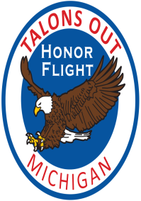
Wow, the holiday event was a huge success!! THANK YOU AGAIN, for all of your donations for the silent auction and charity raffle not to mention those who “Bid High” and “Bid Often” on the silent auction items this year!!!! We raised $7,500 at the holiday party through raffle tickets and the silent auction items. Thank you so much!!!!
So adding that to the $4,368 we raised at our June Golf Outing, the total amount raised was $11,868 for Talons Out Honor Flight.
Thank you for a wonderful year!!!
Please visit the Talons Out Honor Flight website
Below are some things we can do:
How MBTA Members Can Help our 2015 Charity Partner
Great things we as members can do, is to share the Talon’s Out Honor Flight info to our local veterans organizations. Helping to raise awareness and get the word out to our veterans about this wonderful effort is huge. Please contact Kathy Mastin if you’d like to some electronic information you can print out and share.
Finding veterans to fly with Talon’s Out. Print out and carry a couple applications and keep a them in your car. If you see a veteran in your community with a WWII hat. Shake their hand, ask where they served, what branch they were in and ask if they know about honor flight. If not, briefly explain it's an all-expense paid trip to Washington D.C. to visit the memorials built in their honor. It's first apply, first fly and offer up an application.
Apply to be a Guardian. Guardians do pay their portion of the trip ($500) but they can apply to escort a veteran who doesn't have a family member to fly with them. This is one of our most intense, physical but gratifying jobs.
Share Honor Flight: The Movie. It's available on Netflix for download and it's what inspired them to start a Talon’s Out hub. Have tissues ready it's an exciting introduction to Honor Flight.

2014 MBTA Charity Committee
Members: Kathy Mastin, Sandy Chwierut, Jodie Duncan, Gail Major, Jenny Baumann and Kim Burns
The charity chosen for 2014 is “For A Day Foundation”
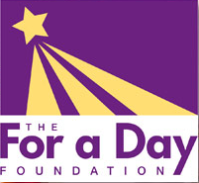
The For A Day Foundation, a 501 (C)(3) organization, formally operated as Queen for a Day, is committed to creating emotionally therapeutic experiences for seriously ill children and providing them and their families with a joyful and much needed diversion from the strain of chronic treatment. We use role models, make believe and play therapy to give each child the opportunity to imagine and live out a fantasy while experiencing a moment of the childhood they all deserve.
http://www.detroitqfad.com/

2014 MBTA Golf Outing raised $2,175 for the For a Day Foundation along with many donations of supplies.
2014 MBTA Holiday Charity Silent Auction and Raffles will also go towards For A Day Foundation
Please feel free to bring donations of any supplies listed below to our October 16th meeting & the December 4th Holiday Meeting. Supplies geared toward children ages 1-21, all new items please.
Gift certificates to businesses such as Michael’s, Office Max, Target, Costco, and WalMart
Teenage Boys – Age appropriate items: books, magazines, blankets, games, etc.
New books for all ages for boys AND girls
Postage Stamps
Teen Magazines
Puzzle Books
Handmade Pillows (tied fleece are a favorite)
Fleece or Hand-made blankets
Bookmarks – A sample saying could read “This bookmark was made with love by ___________”.
Makeup (full size or sample size) – All donated makeup must be new: Lipstick, eye shadow, blush, eyeliners, brow pencil, face/body glitter, nail polish, nail decorations
Makeup Supplies – All donated items must be new: Cotton balls, Q-tips, makeup sponges, eye shadow applicators, nail polish remover, nail files, hand lotion, body lotion, cosmetic bags, and tote bags.
Toys (for Boys & Girls) – All donated items must be new: small sports balls, dolls, coloring books, crayons, puzzles, sticker books, books, cars, hand held games, board games, sports trading cards, small Lego sets, and figurines.
Computer Games & DVD’s – Must be new
Super Hero Capes
Crafts – Must be new: Markers, glitter glue, glue sticks, crayons, foam glue, paper, colored gel pens, foamies (door hangers, letters, shapes, etc.), glue dots, 4x6 photo frames, craft jewels, stickers, beads, jewelry making supplies.
Dress Up Supplies – Must be new: Feather boas, jewelry, gloves, hair clips, tiaras, fireman hats, bandanas, baseball caps.
Paper Products – Plates, napkins, cups plastic table cloths, utensils, gallon size storage bags.
Other – Rolling duffle bags, 4x6 photo paper, Lexmark ink cartridges #32 & 33, inspirational CD’s of relaxing music, music boxes, fun mugs, fun socks (all sizes), acrylic water bottles, hand sanitizer, legal size envelopes, printer paper, and temporary tattoos.

2012 Holiday Meeting
I would like to thank everyone for their generosity at this year's holiday meeting. We raised a total of $7,919 from the raffle and silent auction! This brings our total raised for the Freedom Center this up to $10,170.
2012 Education day
OVBTA was kind enough to split the amount raised in their raffle with MBTA. This allowed us to give an additional $295.00 to the Freedom Center. Thank you OVBTA and everyone who bought a raffle ticket!
2012 Golf Outing
The Freedom Center received $1,956 plus a couple of in-kind donated items from the raffle at the golf outing. Thank you to everyone who donated and helped make a difference at this wonderful charity. Another way we can help support them is by volunteering to work at the Freedom Center. If you are interested in volunteering please go to their website and fill out the application. http://miarmedforceshospitality.org
2012's Chosen Charity
The Charity Committee is pleased to announce The Freedom Center is the MBTA charity for 2012. The Freedom Center was chosen for a number of reasons including it is directly related with travel, has benefited fellow MBTA members, gives back to those who were willing to fight for our freedom, need we say more? We look forward to a successful year of donations to help support this great cause. You can find more information on their website: http://miarmedforceshospitality.org
MISSION STATEMENT: Serving those who serve us...
Our mission is to provide a world-class reception and hospitality center for military personnel at the Detroit Metropolitan Airport. Our goal is to provide a relaxed, home-like atmosphere that embraces and meets the needs of traveling service members and their families. This facility is supported and staffed by individual volunteers and organizations from surrounding communities and the airport. Our doors are open to individuals on active duty, National Guard members, Reservists, and service academy cadets. We also welcome military spouses, dependents, and retirees.
2011 Holiday party donations
Angels of Hope received $4,470 from the silent auction, $855.00 from the raffle sales making a total donation of $5,325.http://angelsofhope.org

Grace Centers of Hope received $1,880 from the live auction and gift card donations plus items from their list of needed items including 50+ suits
http://gracecentersofhope.org

2011 golf outing
QTMC received $2,213 from the silent auction, $335 from the raffle making a total of $2,548.
www.qtmc.com
Operation Kid Equip received in-kind items
www.operationkidequip.org

2009 = $ raised for __ charities
- Dec. raffle $645 - Grace Centers of Hope
- Christmas Auction
- $1,420 Gleaners - SE Michigan Foodbank
- $1,210 Salvation Army
- Auction/Raffle Total: $3,305

2008 = $7,226 raised for 3 charities
- June Auction: $1,690 Habitat for Humanity Detroit
- Christmas Auction: $5536
  - Volunteers of America Michigan: $2677
  - Focus Hope: $2859
2007 = $8,165 raised for 5 charities
- April raffle $160 Project Hope
- June raffle $200 National Arbor Day Foundation
- Dec. raffle $1,200 Solar Cookers International
- Christmas Auction
- $3,760 Gleaners - SE Michigan Foodbank
- $2,845 Salvation Army
- Auction Total: $6,605

2006 = $5,185 raised for 4 charities
- June raffle $475 The Smile Train - Cleft palate surgeries for children
- Dec. raffle $425 TAPS -Survivors of Military killed in action
- Christmas Auction
- $1,845 Gleaners - SE Michigan Foodbank
- $2,440 North Oakland Foundation
- Auction Total: $6,165
- Auction Total: $4,285

2005 = $4,134 raised for 6 charities
- April raffle $209 Project Hope
- June raffle $595 Go-Lightly
- Sept. raffle $770 Red Cross
- Dec. raffle $640 Gleaners Community FoodBank
- Christmas Auction
- $960 ChildHelp USA
- $960 North Oakland Foundation
- Auction Total: $2,560

2004 = $7,290 raised for 4 charities
- June raffle $750 Smile Train
- Dec. raffle $430 Make-a-Wish
- Christmas Auction
- $2,560 Euro-Peds
- $3,550 Salvation Army
- Auction Total: $6,110

2003 = $5,517 raised for 6 charities
- Feb. 50/50 raffle $77 HAVEN (Help Against Domestic Violence Now)
- June rafflle $555 Rose Hill
- Dec. raffle $579 Toys for tots
- Christmas Auction
- $4,885 for Euro-Peds, Salvation Army & Volunteer Impact

2002 = $4,340 raised for 6 charities
- June raffle $400 Food Bank of Oakland County
- Sept. 50/50 $70 Paralyzed Veterans
- Dec. raffle $250 Habitat for Humanity - Western Wayne County Chapter
- Christmas Auction
- $1,075 Gleaners Community Food Bank a Second Harvest network affliate
- $2,000 Make-A-Wish Foundation of Michigan
- $545 The Salvation Army - US Central Region
- Auction Total: $3,620

2001 = $5,300 raised for 4 charities
- Christmas Auction
- $1,600 Open Door Outreach Center
- $1,600 Gleaners Community Food Bank a Second Harvest network affliate
- $1,600 The Salvation Army - US Central Region
- Auction Total: $4,800
- Christmas Raffle $ 500 to Doctors Without Borders

2000 = $5,755 raised for 2 charities
- Aug. 50/50 Raffle = $220 Haven
- Dec. Auction = $5,535 Open Door Outreach

